Magpie Project Task #1 Analysis Questions

1. Provide a screen shot of the chat bot you analyzed here: *(downsize it to be a small picture)*

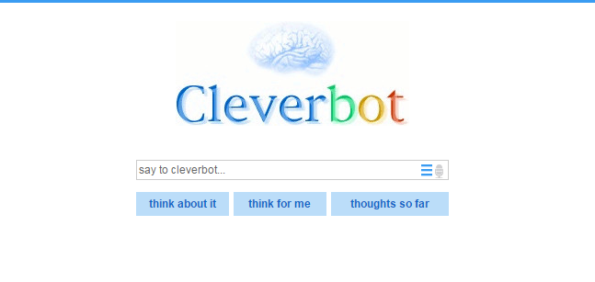

2. What is the URL for the chat bot you found?

http://www.cleverbot.com/

3. Give an examples of three to five keywords or phrases that became clear your chat bot was coded to respond to in a humanlike and appropriate way:

**Example:** *My chat bot responded appropriately when the word "brother" was entered.*

Friend—understood that it relates to people and such

Mario—understood that it was referencing a game

Obama—understood that he was related to a country and was a person

Jesus—understood that he was a person and the story that he came down to earth

4. Describe the types of responses that those keywords were coded to provide.

**Example:** *My chat bot asked about my family when the word "brother" was entered.*

Friend—the responses included talk of friends, best friends, boy/girlfriends

Mario—talked about favorite games

Obama—talked about running a country

Jesus—talked about his father and the bible

|  |  |  |  |  |
| --- | --- | --- | --- | --- |
| 50-59% | 60-69% | 70-79% | 80-89% | 90-100% |
| Some questions have relevant responses. | All questions have relevant responses. | All questions have relevant response and at least three examples are given for questions 3 and 4. | All questions have thorough and relevant responses and at least four examples are given for questions 3 and 4. | All questions have thorough, relevant and expertly explained responses and at least five examples are given for questions 3 and 4. |